Homework 3 Report

Anthony Falcon

In this homework we were tasked with writing 3 subroutines the first 2 are based around Cholesky decomposition. The first of the two is decomposing a matrix into LL* then the second is solving the equation Lx=b by back substitution. Finally, we created a routine that takes a Matrix in and preforms a full QR decomposition on it. To compile the code run `make -f Makefile`.

Problem 1:

* Explain in reasonable detail how the Cholesky decomposition and backsubstitution work.

We can take L and L* multiply them together and set them equal to a Positive Definite Hermitian matrix. Since the matrix is Hermitian we only need to consider either the lower or upper triangular portions. From there we can systematically create a set of equations

* + i = 1:
    - a11=l11l11*
  + I =2:
    - a21=l21l11*
    - a22=l21l21* + l22l22*
  + From here we can see that the pattern repeats itself.

For the back substitution since the output of Cholesky is lower triangular we have already learned a method to solve a system of equations like this from LU decomposition. First solving forward substitution Ly=b then we can solve L*x=y.

* Fit the data with a 3rd-degree polynomial, using single-precision floating point arithmetics. Report what the polynomial coefficients you find are, what the 2-norm error on the fit is, and provide a figure comparing the fitted curve with the data.

|  |  |
| --- | --- |
| Power of coefficient | Coefficients |
| 0 | 0.575 |
| 1 | 4.726 |
| 2 | -11.128 |
| 3 | 7.669 |

For the 3rd degree polynomial we got the following coefficients

Along with the coefficients we got the following for the norm of the vector : 0.193.

Finally we have a graph of the figure along with the graph of the original data.

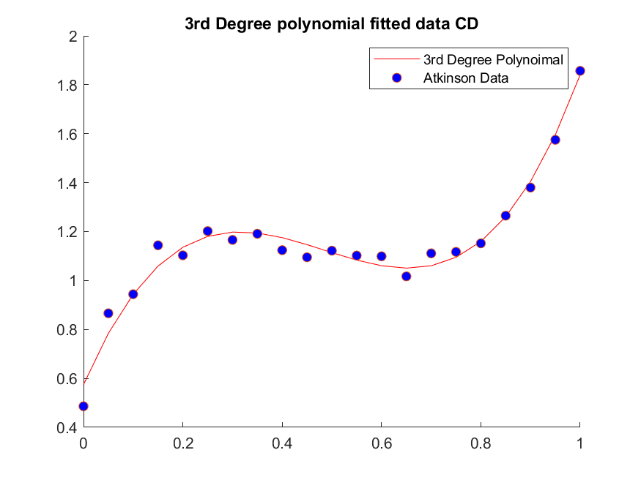

* Fit the data with a 5th-degree polynomial, using single-precision floating point arithmetics. Report what the polynomial coefficients you find are, what the 2-norm error on the fit is, and provide a figure comparing the fitted curve with the data.

Next we solved preformed the same process on the data but instead of fitting it to a 3rd degree polynomial we fitted it to a 5th degree polynomial. The results are as follows

Coefficients:

|  |  |
| --- | --- |
| Power of coefficient | Coefficients |
| 0 | 0.510 |
| 1 | 7.203 |
| 2 | -28.408 |
| 3 | 51.945 |
| 4 | -47.488 |
| 5 | 18.098 |

Norm error of the fit : 0.140.

And the graph comparing the fitted data to the original data.

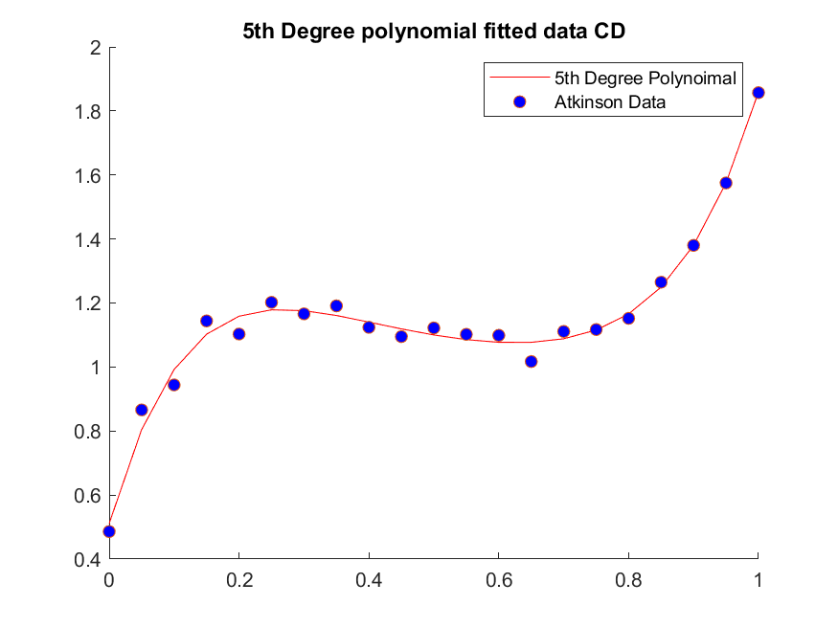

* What should be the maximum degree of polynomials for the given Atkinson data? Explain briefly what happens when you try to fit the Atkinson data with a higher-degree polynomial, and why.

The maximum degree for the polynomial should be 20th since we have 21 data points. When we try to fit the data with a higher-degree polynomial ATb quickly go to numerical zero so the matrix becomes singular/ not positive definite.

* At what point does this algorithm fail (in single-precision floating point arithmetic)? Or, does the algorithm works always? Discuss.

This algorithm fails at 6th degree polynomial using single-precision floating point arithmetic.

Problem 2:

* Explain in detail how the Householder QR decomposition works.

Householder QR decomposition works by taking in the matrix A and returning Q and R by applying orthogonal transformations Hi. Where Hi = I – 2*viv­iT and the i-th iteration of R = R – 2*HiR. From here we can Create QT=HmHm-1…H1.

* Fit the data with a 3rd-degree polynomial, using single-precision floating point arithmetic. Report what the polynomial coefficients you find are, what the 2-norm error on the fit is, and provide a figure comparing the fitted curve with the data (again, you will need to use the Vandermonde matrices).

For the 3rd-degree polynomial we get out the following coefficients:

|  |  |
| --- | --- |
| Power of Coefficient | Coefficient |
| 0 | 0.575 |
| 1 | 4.726 |
| 2 | -11.128 |
| 3 | 7.669 |

The 2-norm error on the fit is: 0.0193

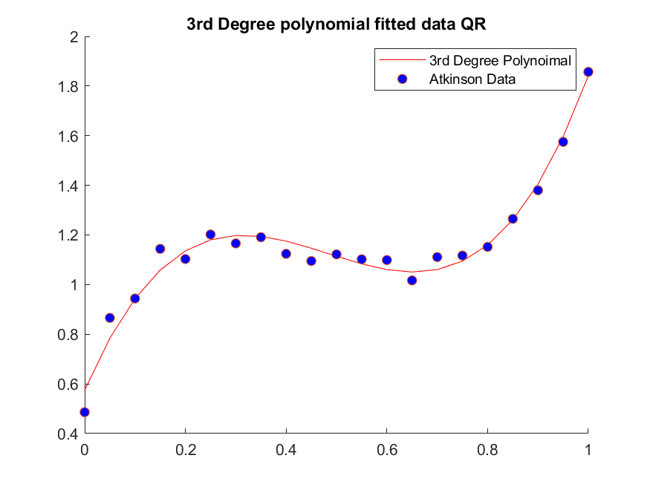Below is a figure comparing the fitted curve alongside the original data:

* Fit the data with a 5th-degree polynomial, using single-precision floating point arithmetic. Report what the polynomial coefficients you find are, what the 2-norm error on the fit is, and provide a figure comparing the fitted curve with the data.

For the 5th degree polynomial the coefficients are

|  |  |
| --- | --- |
| Power of Coefficient | Coefficient |
| 0 | 0.510 |
| 1 | 7.203 |
| 2 | -28.408 |
| 3 | 51.945 |
| 4 | -47.488 |
| 5 | 18.098 |

The 2-norm of the fitted curve and the original data is: 0.140

Once again below is a graph comparing the fitted values with the original values:

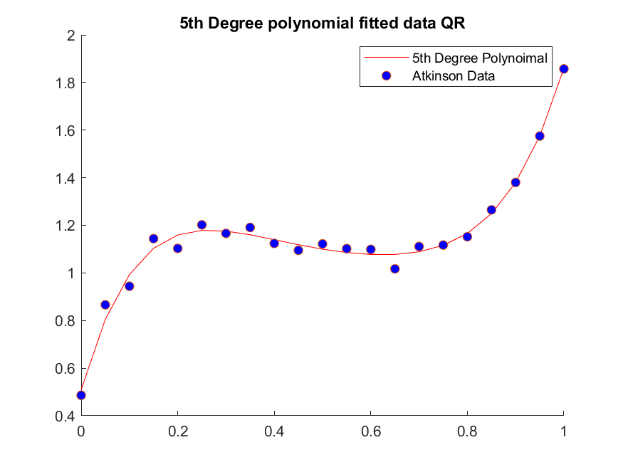

* At what point does this algorithm fail (in single-precision floating point arithmetic)? Or, does the algorithm works always? Discuss.

This algorithm works as long as the interpolated polynomial degree is less than the number of data point you have. This algorithm always works in that case since it doesn’t depend on the normal equation. Which makes this method is much less sensitive than the normal equation. Which gives us the ability to compute larger polynomials than Cholesky.

* For the 5th order polynomial case, discuss your findings about the 2-norms of A − QR and QTQ−I.

The norm of A-QR was 2.283E-6 which is near machine error for single precision and the norm of QTQ−I was 1.829E-6 again is very near machine error for single precision.